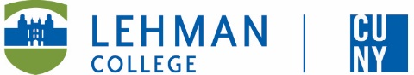

Leonard Lief Library

Latin American and Latino Studies

present

A Reading and Discussion

**Dictatorship Across Borders**

**Brazil, Chile, and the South American Cold War**

**by Mila Burns**

A trailblazing analysis of Brazil’s influence on the 1973 Chilean *coup d'état* - this book offers a groundbreaking perspective on the 1973 Chilean coup. It highlights Brazil’s pivotal role in shaping the political landscape of South America during the Cold War. Shifting the focus from the United States to interregional dynamics - Mila Burns argues that Brazil was instrumental in the overthrow of Salvador Allende and establishment of Augusto Pinochet’s dictatorship.

Drawing on original documents, interviews, and newly accessible archives - particularly from the Brazilian Truth Commission - Burns reveals Brazil’s covert involvement in the coup, providing weapons, intelligence, and even torturers to anti-Allende forces.

She also explores resistance networks formed by Brazilian exiles in Chile. Burns’ impeccable research - combining history, anthropology, and political science - makes Dictatorship Across Borders a vital addition to Cold War studies, reshaping how we understand power and resistance in South America.

**Mila Burns** is Associate Professor of Latin American and Latino Studies at Lehman College.

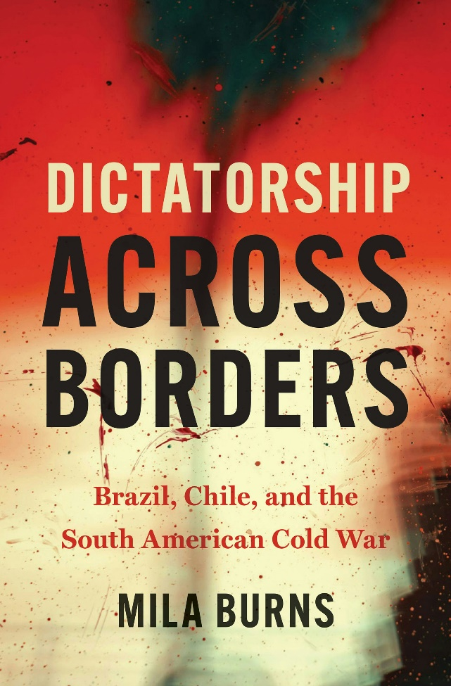

**Wednesday, September 17, 2025**

**12:00 - 1:00 PM**

RSVP by September 16th: <https://libcal.lehman.edu/event/15269915>

Location:Library - Treehouse Conference Room 317

*\*Registration is required\**

Information: [Bernice.Suphal@lehman.cuny.edu](mailto:Bernice.Suphal@lehman.cuny.edu)