

Leonard Lief Library

Philosophy

present

A Reading and Discussion

**Multiplicity, Belonging, and Free Speech in U.S. Higher Education: Thriving through Current Crises**

**by Naomi Zack**

New realities in U.S. higher education present a multifaceted crisis for students, faculty, administrators, and society at large. This book provides incisive diagnoses of pressing problems and prescriptions to reinstate and support U.S. higher education as an intellectually and ethically valuable institution.

Among problems addressed are: Supreme Court ban of affirmative action; falling enrollment and low retention; defunded humanities; unjust situation of adjunct instructors; college firsts confronting social class; student mental health and microaggressions; disruptive free speech; mind-numbing effects of AI; campus insecurity; and anti-intellectual ideological political pressure.

**Naomi Zack** is Distinguished Professor of Philosophy at Lehman College and CUNY Graduate Center.

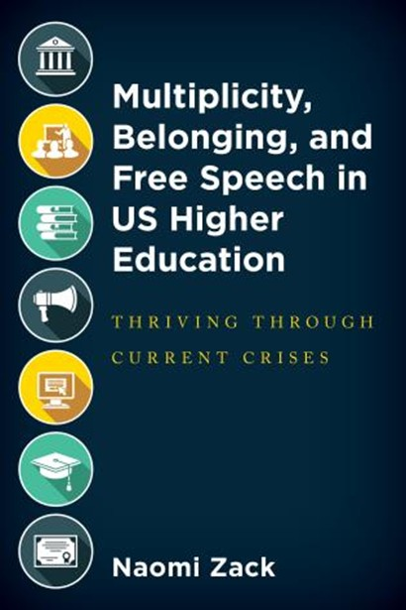

**Tuesday, April 22, 2025**

**12:00 - 1:00 PM**

RSVP by April 21st: https://libcal.lehman.edu/event/14374361

Location:Library - Treehouse Conference Room 317

*\*Registration is required\**

Information: [Vanessa.ArceSenati@lehman.cuny.edu](mailto:Vanessa.ArceSenati@lehman.cuny.edu)