

Leonard Lief Library

English

present

A Reading and Discussion

**Rhetoric and Resistance**

**The Literary Arts of Dissent in Nineteenth-Century Britain**

**by Maeve Adams**

*Rhetoric and Resistance* explores the transformative role of 19th century literature in shaping modern concepts and practices of democratic dissent.

By examining works of Romantic and Victorian novelists, poets, and journalists - Maeve Adams identifies origins of modern theories and practices of resistance in 19th century literary forms.

Offering a literary history of dissent - the book recovers the intertwined development of democracy and aesthetics, revealing how narrative form became a potent tool for challenging authority.  
  
Tracing the lineage of dissent from the radical fiction and journalism of the 1800s to contemporary movements like #MeToo - Adams offers a genealogy that highlights how literary texts experimented with political power, granting new and consequential voices to working class individuals, women, colonized peoples, and other marginalized groups.

**Maeve Adams** is Assistant Professor of English at Lehman College.

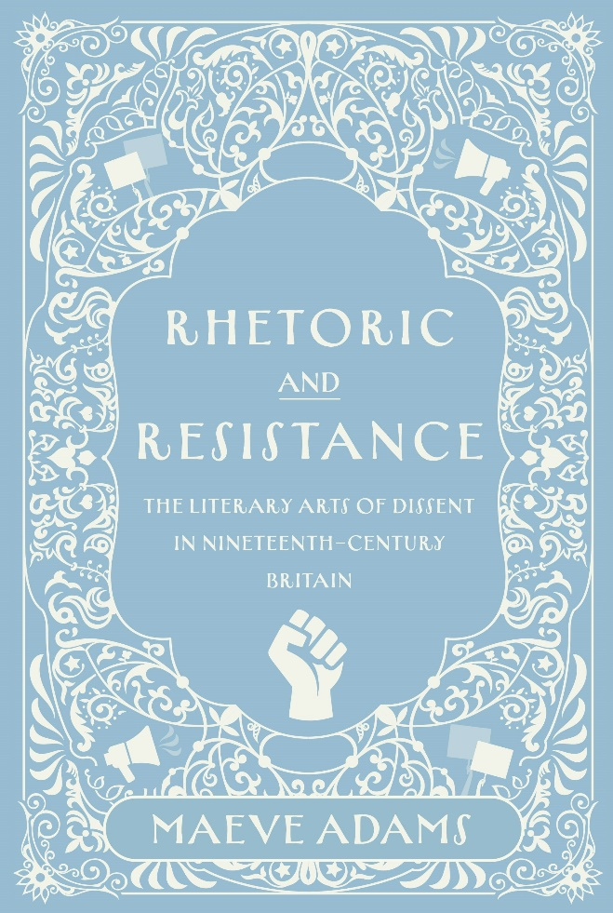

**Tuesday, October 21, 2025**

**12:00 - 1:00 PM**

RSVP by October 20th: [https://libcal.lehman.edu/event/15520276](https://nam02.safelinks.protection.outlook.com/?url=https%3A%2F%2Flibcal.lehman.edu%2Fevent%2F15520276&data=05%7C02%7CBERNICE.SUPHAL%40lehman.cuny.edu%7Ce6774e886d7a4b2a990d08de05ce7865%7C6f60f0b35f064e099715989dba8cc7d8%7C0%7C0%7C638954581555762992%7CUnknown%7CTWFpbGZsb3d8eyJFbXB0eU1hcGkiOnRydWUsIlYiOiIwLjAuMDAwMCIsIlAiOiJXaW4zMiIsIkFOIjoiTWFpbCIsIldUIjoyfQ%3D%3D%7C0%7C%7C%7C&sdata=I%2FEMc2iZqqU2caQFvGoG5XfZwcNC2RWSzUkeFO%2BZHoE%3D&reserved=0)

Location:Library - Treehouse Conference Room 317

*\*Registration is required\**

Information: [Bernice.Suphal@lehman.cuny.edu](mailto:Bernice.Suphal@lehman.cuny.edu)