

Leonard Lief Library

Africana Studies

present

A Reading and Discussion

**Frederick Douglass: A Life in American History**

**by Mark Christian**

Chronicling Frederick Douglass' life in an accessible way - this biography engages with history and wrestles with biases, falsehoods, and unknown facts to tell Douglass' story. Taking a comprehensive look at Douglass' life - the book delves into his time as an enslaved African American, his escape, his experiences as a prominent orator and champion of Black rights, and the influence he had on shaping society of the time.

A detailed timeline allows readers to quickly reference major points in Douglass' history. The book is further augmented by primary documents, including samples of Douglass' own copious works. Readers will come away with not only a better understanding of American history - but appreciation for Frederick Douglass' impact on his time and lasting relevance for those who continue to fight for a more equal society.

**Mark Christian** is Professor in Lehman College’s Africana Studies Department.

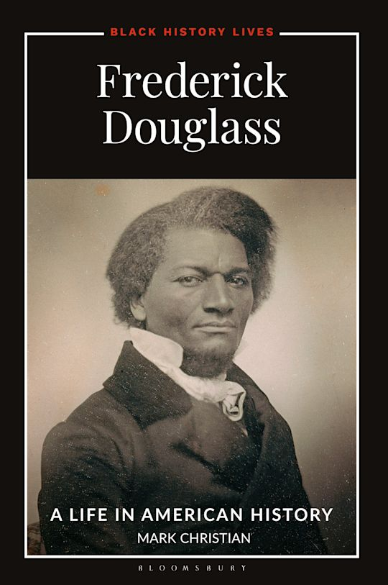

**Wednesday, February 26, 2025**

**12:00 - 1:00 PM**

RSVP by February 25th: [**https://libcal.lehman.edu/event/14057646**](https://libcal.lehman.edu/event/14057646)

Location:Library - Treehouse Conference Room 317

*\*Registration is required\**

Information: [Vanessa.ArceSenati@lehman.cuny.edu](mailto:Vanessa.ArceSenati@lehman.cuny.edu)