Purchase Orders

BUSINESS OBJECTIVE: The Procurement Department also known as Purchasing Office finalizes purchase orders thru an extensive due diligence and compliance process. The Procurement Department is the only university authority that will send a fully executed Purchase Order to the vendor and will copy the requestor.
NOTE: The Requestor or department personnel must not provide the vendor with the Purchaser Order number prior to the receipt of a fully executed Purchase Order from their Procurement Department.

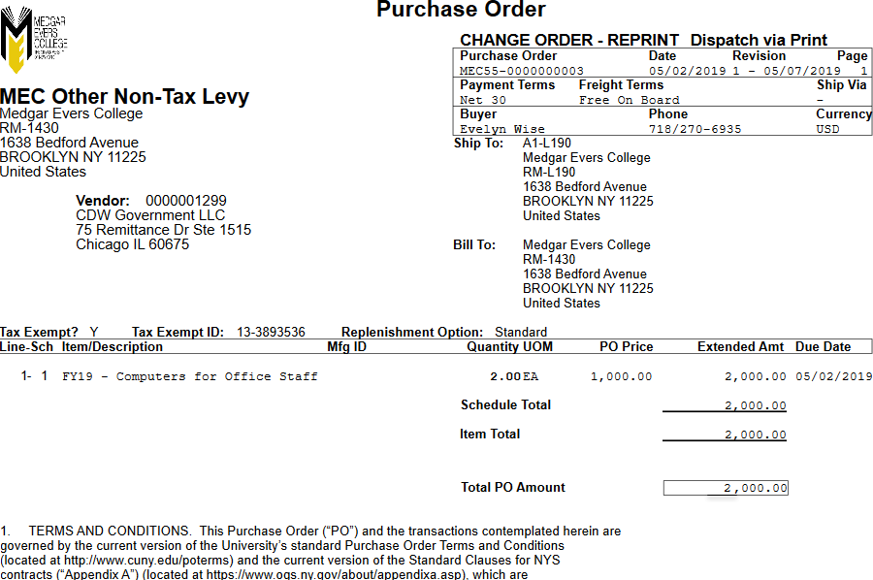
MPLE PURCHASE OR

